HISTOGRAM
Pearson Edexcel - Monday 12 November 2018 - Paper 3 (Calculator) Higher Tier
1.
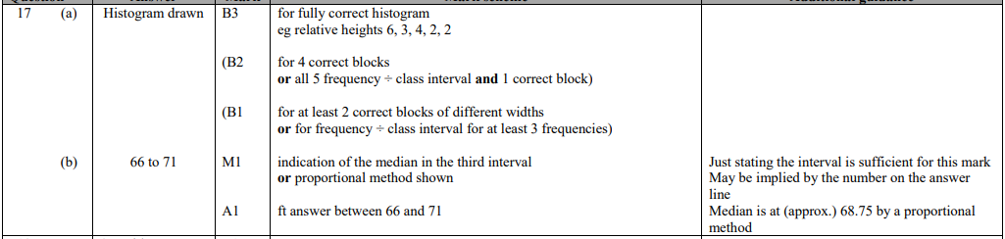
Pearson Edexcel - Monday 6 November 2017 - Paper 2 (Calculator) Higher Tier
2.
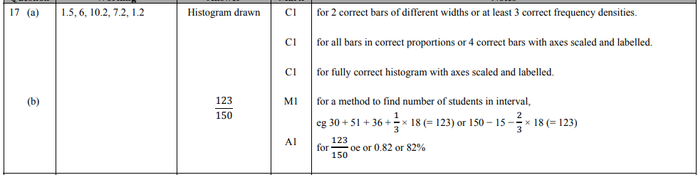
Pearson Edexcel - Specimen Papers Set 2 - Paper 3 (Calculator) Higher Tier
3.
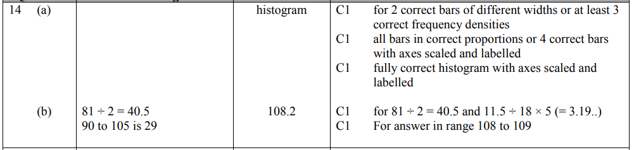
Pearson Edexcel - Sample Paper 1 - (Non-Calculator) Higher Tier
4.
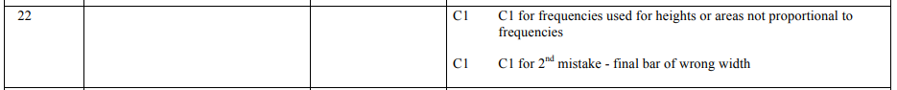
Pearson Edexcel - Thursday 9 June 2016 - Paper 2 (Calculator) Higher Tier
5.
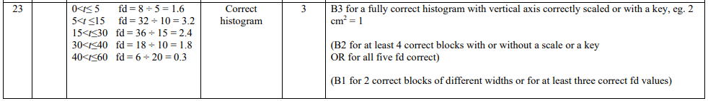
Pearson Edexcel - Friday 7 November 2014 - Paper 2 (Calculator) Higher Tier
6.
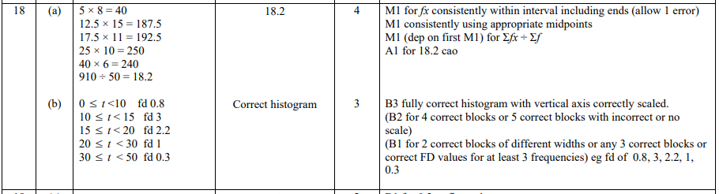
Pearson Edexcel - Tuesday 11 June 2013 - Paper 1 (Non-Calculator) Higher Tier
7.
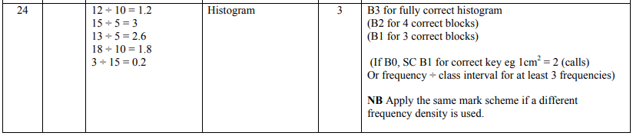
Pearson Edexcel - Monday 4 March 2013 - Paper 2 (Calculator) Higher Tier
8.
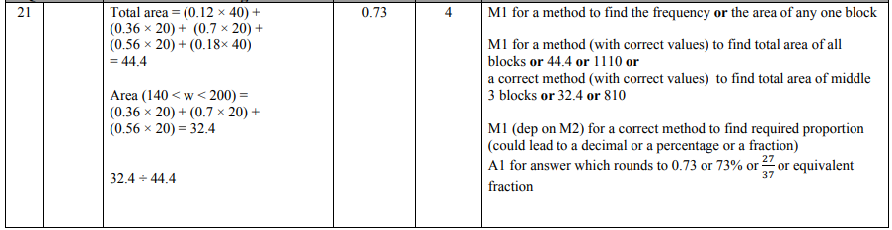
Pearson Edexcel - Thursday 8 November 2012 - Paper 2 (Calculator) Higher Tier
9.
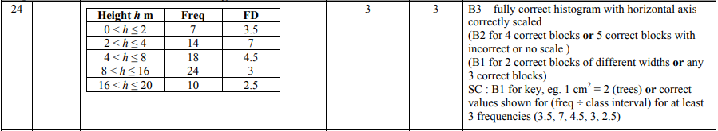
Pearson Edexcel - Monday 11 June 2012 - Paper 1 (Non-Calculator) Higher Tier
10.
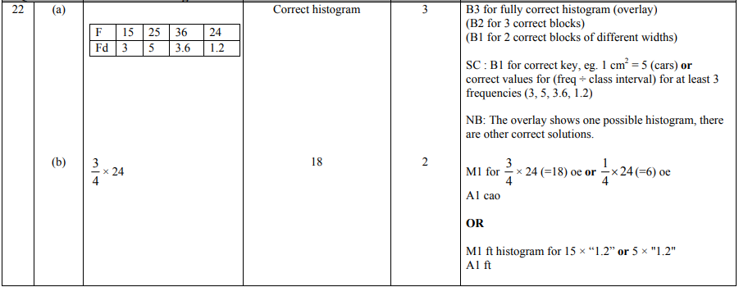
Pearson Edexcel - Monday 5 March 2012 - Paper 4 (Calculator) Higher Tier
11.
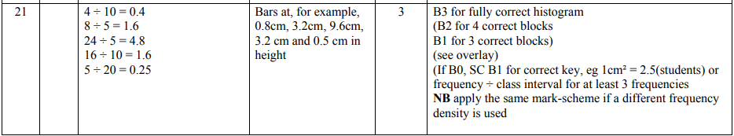
Pearson Edexcel - Monday 14 November 2011 - Paper 4 (Calculator) Higher Tier
12.
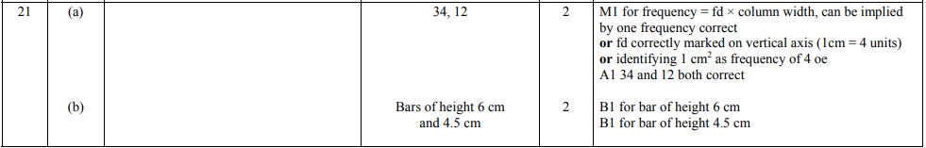
Pearson Edexcel - Monday 6 June 2011 - Paper 3 (Non-Calculator) Higher Tier
13.
Pearson Edexcel - Tuesday 9 November 2010 - Paper 3 (Non-Calculator) Higher Tier
14.
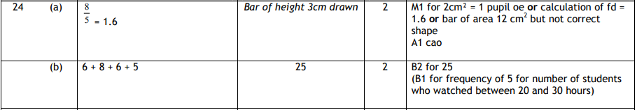
Pearson Edexcel - Friday 11 June 2010 - Paper 4 (Calculator) Higher Tier
15.
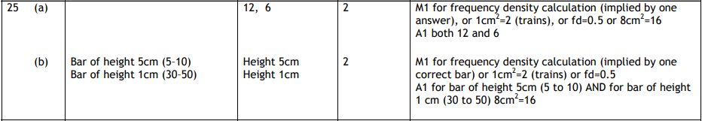
Pearson Edexcel - Tuesday 10 November 2009 - Paper 4 (Calculator) Higher Tier
16.
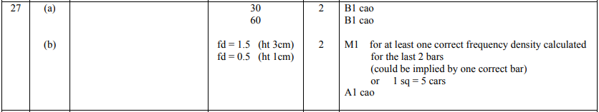
OCR GSCE – Thursday 5 November 2020 – Paper 5 (Non-Calculator) Higher Tier
17.
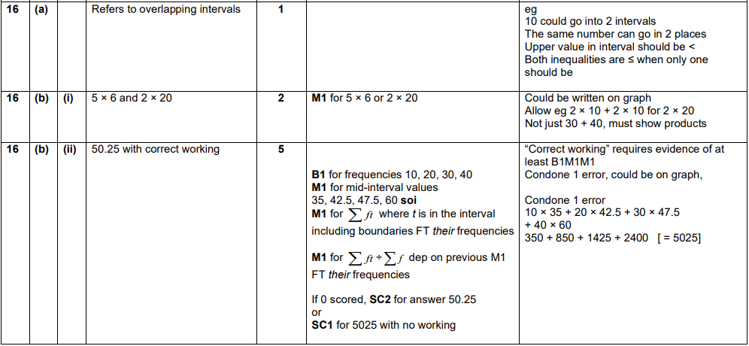
OCR GSCE – Monday 11 November 2019 – Paper 6 (Calculator) Higher Tier
18.
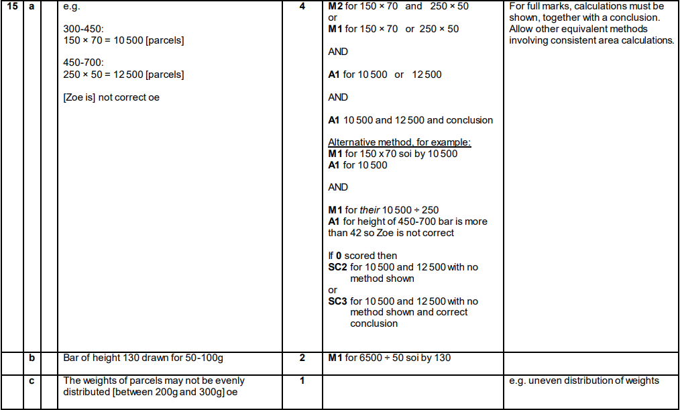
OCR GSCE – Tuesday 6 November 2018 – Paper 4 (Calculator) Higher Tier
19.
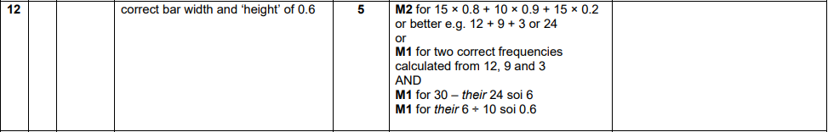
OCR GSCE – Tuesday 2 November 2017 – Paper 4 (Calculator) Higher Tier
20.
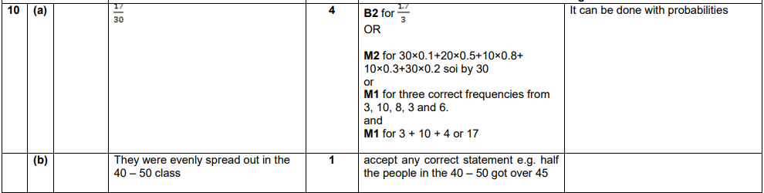

OCR GSCE – Tuesday 13 June 2017 – Paper 6 (Calculator) Higher Tier
21.
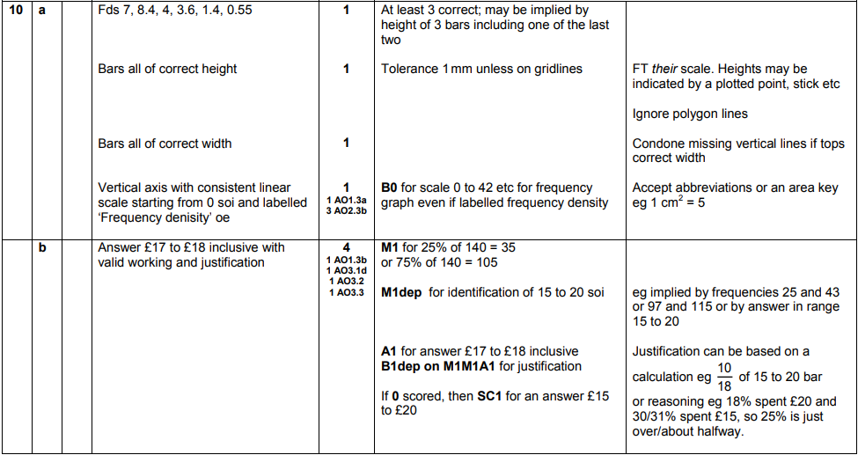
AQA GSCE – Tuesday 19 May 2020 – Paper 1 (Non - Calculator) Higher Tier
22.
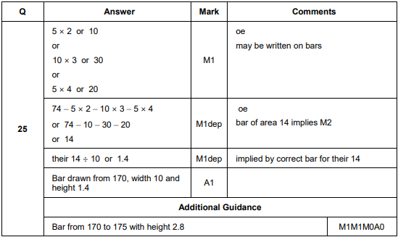
AQA GSCE – Monday 12 November 2018 – Paper 3 (Calculator) Higher Tier
23.
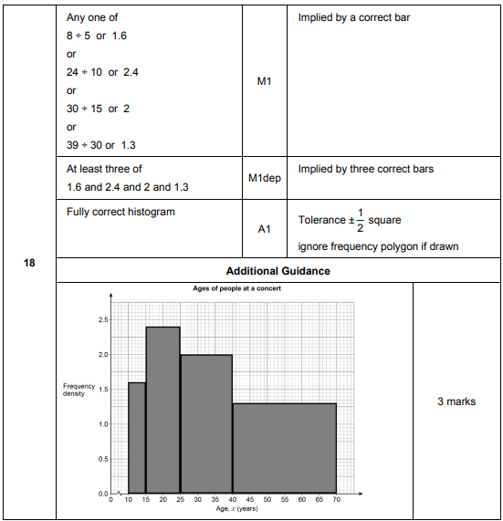
AQA GSCE – Tuesday 12 June 2018 – Paper 3 (Calculator) Higher Tier
24.
